ICT202
Natural language processing and topic modelling
Topic Modelling of Ukraine Conflict Discourse on Twitter (10-14 June 2023)

Introduction:
Understanding public discourse during major geopolitical events has become increasingly dependent on analysing large volume of social media text. Twitter provides rapid, real-time reflections of public sentiment, reactions to breaking news, and the spread of political narratives. This assignment investigates the thematic structure of twitter discussions surrounding the 2022-2023 Russia-Ukrainian was using unsupervised topic modelling techniques. The central research question is: what domain themes emerge on English-Language tweets during a concentrated period of the conflict, and how effectively can different topic modelling methods capture these themes?
The study focuses on a carefully selected group of tweets taken from a public Kaggle dataset [1], which have been filtered to maintain consistent language and make analysis practical. Given the noisy, short, and highly variable nature of tweets, that analysis incorporates a series of preprocessing steps to reduce sparsity and enhance interpretability. Multiple modelling approaches (BERTopic, DBSCAN, K-Means Clustering) are applied to the same corpus to compare their strengths, limitations, and suitability for short-text topic extraction. The evaluation combines quantitative metrics with qualitative inspection to assess model performance. Overall, the study aims to demonstrate how unsupervised methods can uncover meaningful patterns in real-world social media data despite inherent challenges.

Data Collection and Preprocessing
To prepare the dataset for topic modelling, a series of cleaning and normalisation steps were applied to reduce noise, ensure linguistic consistency, and improve the interpretability of the tweets. Table 1 summarises each preprocessing steps and its underlying rationale.
Step | Description | Rationale
- Language Filtering | Retained only tweets labelled as English (Language = ‘en’) | Ensures all topics are interpretable within a single language and prevents cross-lingual noise.
- Remove missing and duplicate text | Dropped tweets with empty text fields and removed duplicates | Missing text adds no semantic value; duplicates distort word frequencies.
- Remove very short Tweets | Excluded tweets with =< 20 characters | Extremely short tweets often contain only URLs or mention and lack meaningful content.
- Random sampling (10,000 tweets) | Selected a random subset using seed = 42 | Balances computational efficiency with topical diversity; exceeds assignment minimum.
- Lowercasing | Converted all text to lowercase | Standardises tokens and reduces vocabulary fragmentation
- Remove URLs and Mentions | Removed hyperlinks and @user mentions | Eliminates non-semantic noise common in twitter data.
- Remove non-Alphabetic characters | Stripped numbers, punctuation, and symbols | Reduces sparsity and focuses analysis on meaningful lexical content
- Tokenisation | Split text into individual tokens | Required for downstream NLP operations
- Stopword removal | Removed English stopwords using NLTK. [2] | Eliminates high-frequency, low-information words
- Stemming (porter Stemmer) | Reduced words to their stem forms | Decreases vocabulary size and strengthens co-occurrence patterns. [3]

These preprocessing steps collectively produced a cleaner and more standardised corpus suitable for topic modelling. By removing noise, reducing sparsity, and ensuring linguistic consistency, the resulting dataset provided a stable foundation for the modelling techniques described in the next sections.
Topic Modelling: Methods and Explanation
topic modelling aims to uncover latent themes within a collection of documents by analysing patterns of word co-occurrence. Conceptually, models such as LDA assume that each document is a mixture of topics, and each topic is a probability distribution over words. Although LDA was considered, this analysis focused on three alternative approaches BERTopic, K-Means clustering, and DBSCAN, chosen for their contrasting assumptions and suitability for short-text data.
BERTopic was selected because it combines transformer-based embeddings with class-based TF-IDF, making it particularly effective for short, noisy texts like Twitter [4]. Transformer embeddings capture contextual meaning beyond simple word frequency, while HDBSCAN identifies dense clusters and assigns ambiguous tweets to a noise class. This avoids forcing every tweet into a topic and improves interpretability. c-TF-IDF then extracts representative words for each cluster. BERTopic produced coherent topics such as dam destruction, counteroffensive updates, NATO diplomacy, and US political commentary. The presence of dedicated noise topic (Topic -1) reflects HDBSCAN’s ability to isolate low-density tweets. A coherence score of 0.4431 indicates moderate internal consistency, which is reasonable for short-text tweets.
K-Means Clustering, applied to a TF-IDF matrix, was included as a transparent and widely used baseline. TF-IDF was chosen because it emphasizes discriminative terms and handles spares, high-dimensional text well. The choice of K= 5 was based on interpretability, cluster size balance, and the need to avoid over fragmentation [8]. K-Means assigns every tweet to a cluster, ensuring full coverage but sometimes forcing ambiguous tweets into less suitable categories.
DBSCAN was included to explore density-based clustering, which can reveal highly specific micro-topics and naturally identify noise [5]. Hyperparameters such as (eps) and (min-samples) were tuned iteratively to avoid trivial all-noise out single-clustering outcomes. While DBSCAN successfully identified niche clusters, its performance was limited by the sparsity of TF-IDF vectors, resulting in a high noise fraction.
Overall, BERTopic offered the best balance of semantic richness, interpretability, and quantitative quality.

Unsupervised Evaluation
- Evaluating unsupervised topic models requires a combination of quantitative metrics and qualitative inspection. For BERTopic, the c_v Coherence score of 0.4431 provides a numerical indication of how strongly the top words within each topic co-occur in the corpus. While not exceptionally high, this value is consistent with expectations for short, noisy texts such as tweets. Qualitative inspection of top-n words and representative tweets confirmed that several topics like dam destruction, frontline updates, and NATO diplomacy, were semantically coherent and aligned with real-word events during the selected period. Figures below highlight the top words for the first 4 topic.
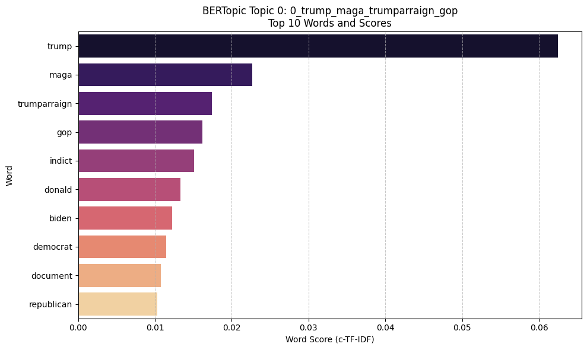
Figure 1. top 10 words for BERTopic Topic 0

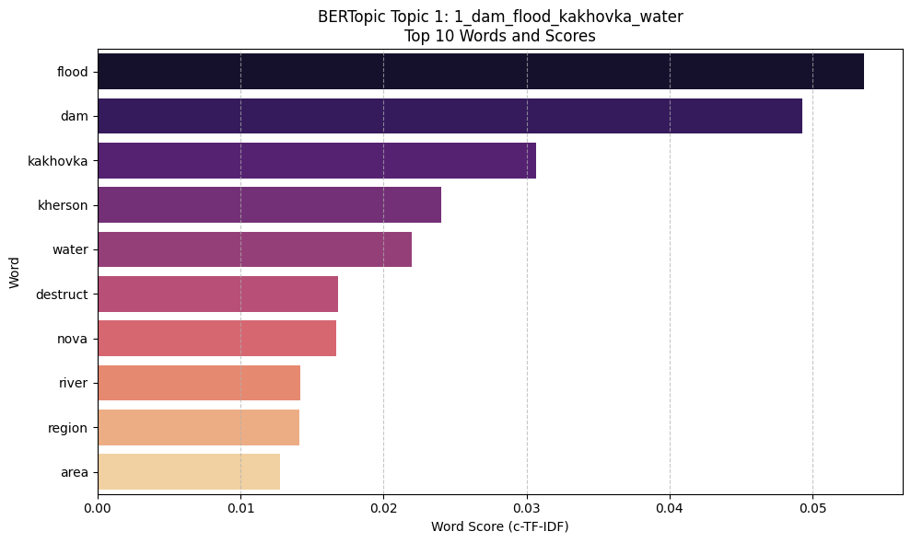
Figure 2. top words for BERTopic topic 1

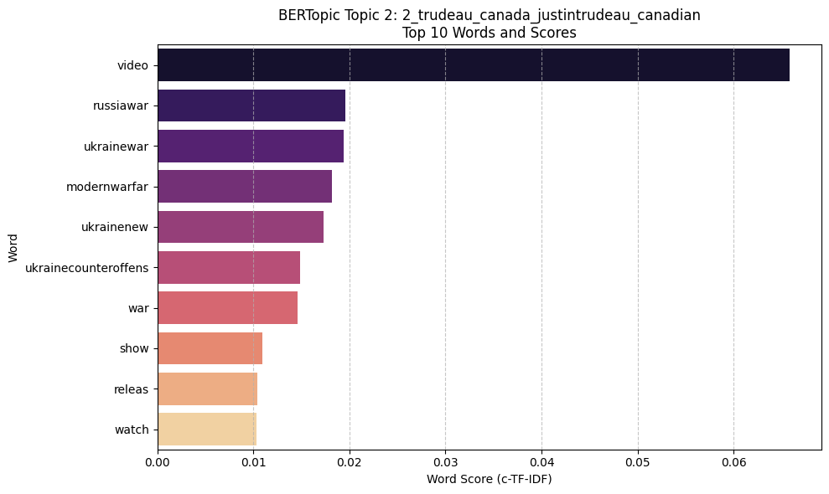
Figure 3. top words for BERTopic topic 2.

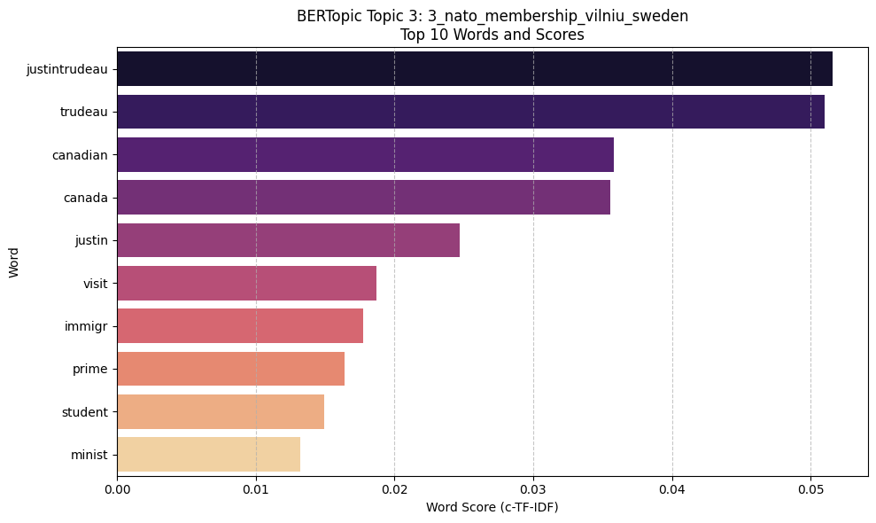
Figure 4. top words for BERTopic topic3.

- K-Means evaluates relied on intertie and cluster size distribution. The clusters were reasonably balanced, suggesting that K= 5 provided a practical compromise between granularity and over-fragmentation [8]. Manual inspection of top TF-IDF terms revealed clear thematic distinctions, through some clusters contained mixed content due to the limitation od Euclidean distance in high-dimensional sparse space.
Cluster | size
0 | 5,540
1 | 761
2 | 1,468
3 | 1,598
4 | 633

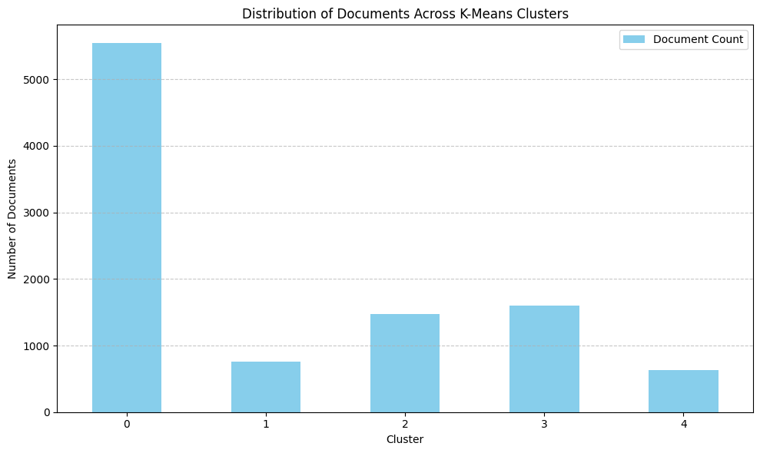
Figure 5. Distribution of documents across K-Means clusters.

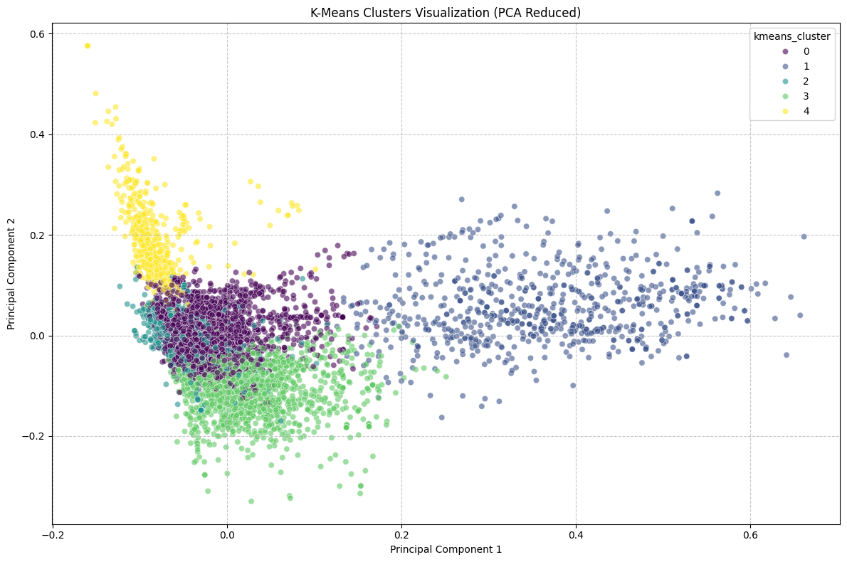
Figure 6. PCA projection of K-Means clusters.

- DBSCAN’s evaluation focused on the proportion of points labelled as noise [9]. The high noise fraction indicated that relatively few tweets formed dense regions in TF-IDF space, reflecting the method’s sensitivity to sparsity while DBSCAN successfully identified niche micro-topics, its overall performance was limited.
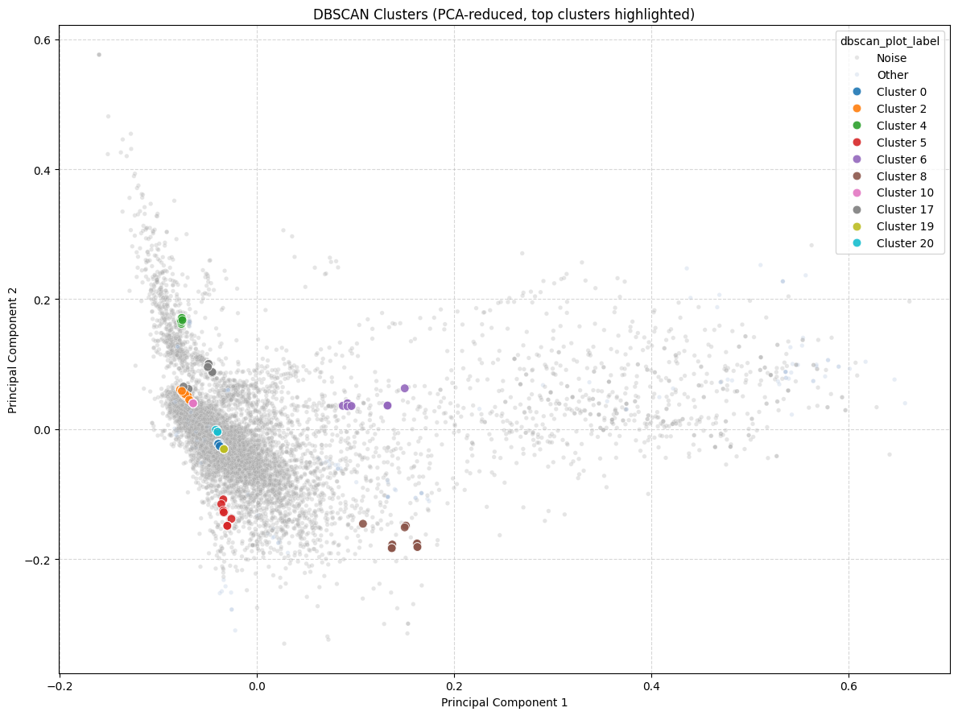
Figure 7. DBSCAN PCA plot showing dense micro-clusters and a large noise cloud.

- Latent Dirichlet Allocation (LDA) was also considered as a potential modelling technique.[7] LDA is a generative probabilistic model in which each document is represented as a mixture of latent topics, and each topic is a probability distribution over words. Although LDA is a common choice in traditional topic modelling, it yields the most reliable results with longer documents where word co-occurrence patterns remain more consistent. Tweets, by contrast, are extremely short and sparse, which limits LDA’s ability to infer meaningful topic distributions. Preliminary inspection showed the LDA produced less coherent topics compared to BERTopic and K-Means, largely because the short length of tweets violates LDA’s underlying assumptions about word distributions. For this reason, LDA was not selected as a primary model, but it provides a useful conceptual baseline for understanding how probabilistic topic models differ from embedding-based and clustering-based approaches. PCA visualisation shows diffuse, overlapping clusters, reflecting LDA’s limitation on short text.

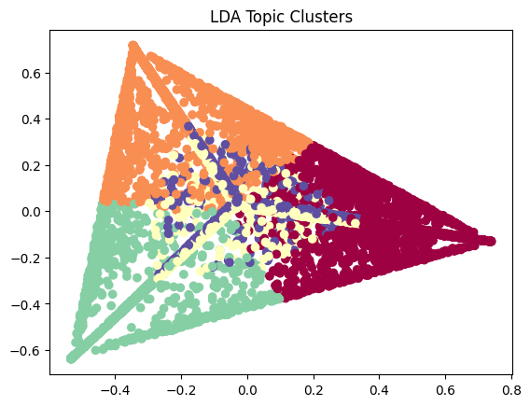
Figure 8: LDA topic clusters visualised in two-dimensional space. Each point represents a tweet projected into a reduced topic space, with colours indicating the dominant topic assigned by the LDA model. The triangular structure reflects the separation between major topics, while the spread of points within each region illustrates variation in word distributions across documents. The visualisation highlights how LDA groups tweets into distinct thematic clusters despite the short and noisy nature of the text.

- Fuzzy C-means was also considered as an alternative to K-Means.[10]Unlike K-Means, which assigns each document t exactly one cluster, fuzzy c-means assigns membership probabilities, allowing tweets to belling partially to multiple topics. This soft clustering approach can be advantageous when documents contain overlapping themes. However, fuzzy c-means is sensitive to noise and performs poorly in high-dimensional sparse spaces such as TF-IDF representations of tweets. It also requires carful tuning of fuzziness parameters and is computationally more expensive than K-Means. Given these limitations, and the fact the tweets often contain very few words, k-means provided a more stable and interpretable clustering baseline of this dataset.

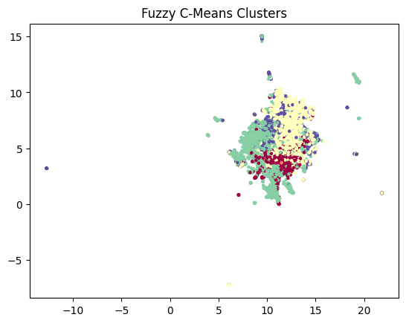

Figure 9: Fuzzy C-Means clustering of tweet embeddings. Each point represents a tweet, coloured by its highest membership degree. The smooth colour transitions and overlapping regions illustrate the soft boundaries between clusters, showing how many tweets share partial membership across multiple themes. The dense central region reflects the concentration of mixed or blended topics commonly found in short, noisy Twitter data.
- For dimensionality reduction and visualisation, UMAP (Uniform Manifold Approximation and Projection) was considered as an alternative to PCA. [6] UMAP can preserve both local and global structure in high-dimensional data and often produces clearer cluster separation in embedding-based models. However, PCA was chosen for this analysis due to its simplicity, interpretability, and lower computational cost. PCA provides a straightforward linear projection the is easy to explain in the context of TF-IDF features. UMAP remains a valuable alternative for future work, particularly when working with dense embedding vectors such as those produced by transformer models.
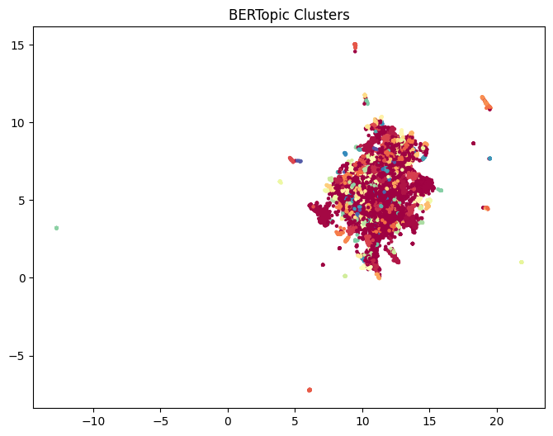

Figure 10. UMAP visualisation of BERTopic clusters.
This scatter plot shows the distribution of BERTopic-generated topics in a 2-dimensional embedding space. While several topics form identifiable regions, many points overlap, reflecting the semantic complexity and interconnected nature of Ukraine-related Twitter discourse. The widespread dispersion of points also highlights the presence of a large noise topic.

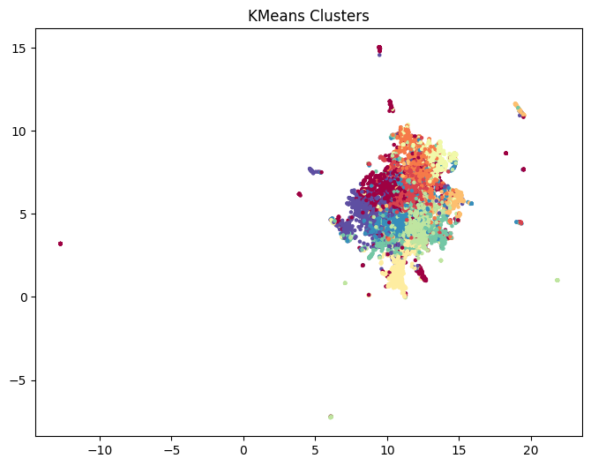
Figure 11. UMAP visualisation of Fuzzy C-Means clusters.
This scatter plot illustrates the Fuzzy C-Means cluster assignments in a 2-dimensional embedding space. The overlapping regions reflect the fuzzy membership structure, where tweets can belong to multiple clusters simultaneously. This visualisation demonstrates FCM’s ability to capture nuanced, blended themes within the dataset.

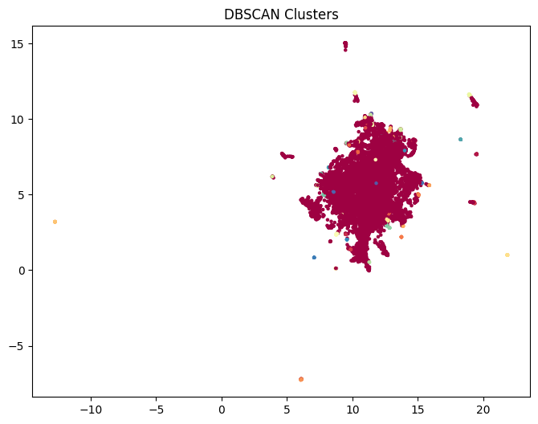
Figure 12. UMAP visualisation of DBSCAN clusters. This figure shows DBSCAN’s clustering structure in UMAP-reduced space. A small number of compact, dense clusters appear clearly, while most points form a large noise cloud. This visual pattern aligns with DBSCAN’s behaviour on sparse short-text data, where only highly repetitive or tightly similar tweets form clusters.

All models consistently identified key themes—such as the Kakhovka dam, battle of Bakhmut, NATO membership, and anti-Putin sentiment—highlighting their significance in public discourse. Despite different methods, the thematic structure proved robust. Each model also offered distinct insights: DBSCAN found repetitive messages, while FCM revealed blended themes, underscoring the benefits of using multiple approaches.

Evaluation
- Coherence scores
Model | Coherence(c_v)
DBSCAN | 0.875
BERTopic | 0.619
K-Means | 0.504

Coherence scores provided an indication of how semantically consistent the top words within each topic are. [11] DBSCAN achieved the highest coherence (0.875), which reflects its tendency to form extremely tight, repetitive micro-clusters often capturing near-duplicate tweets or coordinated messaging. BERTopic achieved a moderate coherence score (0.619), balancing semantic richness with broad topical coverage. K-Means produced the lowest coherence (0.504), consistent with its more diffuse cluster and reliance on TF-IDF rather than contextual embeddings. These results highlight hoe different modelling assumptions influence topic compactness and interpretability.

- Internal validity metrics
Model | Silhouette | Davies-Bouldin | Calinski-Harabasz
BERTopic | -0.0198 | 2.875 | 17.85
K-Means | 0.0171 | 4.613 | 173.17
DBSCAN | -0.119 | 1.371 | 13.05

Internal validity metrics provide a complementary view of cluster structure. K-Means achieved the highest Calinski-Harabasz score, indicating well-separated centroids and balanced cluster sizes. DBSCAN performed based on the Davies-Bouldin index, reflecting its compact micro-clusters and strong internal cohesion. Silhouette scores were low across all models, which is expected for high-dimensional sparse text data where distances between points tend to be small and overlapping. Together, these metrics show that each model captures a different aspect of the dataset.

Discussion
Across all models, several dominant themes consistently emerged such as the Kakhovka dam disaster, the battle of Bakhmut, NATO membership debates, and anti-Putin sentiment, indicating a robust underlying structure in the dataset. At the same time, each method contributed unique insights: DBSCAN revealed dense, repetitive patterns suggestive of coordinated or bot-like activity, while fuzzy c-means highlighted overlapping themes that reflected the multifaceted nature of many tweets. LDA produced interpretable word distributions but struggled with short text, whereas BERTopic offered the strongest semantic coherence for real-word discourse. Taken together, these models provide a multi-resolution understanding of Ukraine-related Twitter conversations, demonstrating the value of a multi-model evaluation approach.
Conclusion
The study applied five unsupervised topic modelling methods to a dataset of 10,000 Ukraine-related tweets, revealing how different algorithms capture distinct layers of public discourse. Among the models, BERTopic produced the most coherent and interpretable topics, consistently identifying major themes such as the Kakhovka dam disaster, NATO developments, and the spillover of US political datasets. K-Means offered board thematic organisation with full coverage of the dataset, while DBSCAN uncovered dense micro-clusters and a substantial amount of noise, highlighting repetitive or coordinated messaging. LDA generated interpretable word distributions but struggled with the short, sparse nature of tweets, whereas fuzzy c-means emphasised overlapping themes through its soft-membership structure.
The analysis noted key limitations: noisy Twitter data, short posts, and off-topic content like US politics or unrelated conflicts. Future work could incorporate temporal topic tracking, sentiment analysis, or user-level metadata to distinguish organic conversation from coordinated activity. Overall, the combined use of multiple models provides a richer and more nuanced understanding of how people discuss major geopolitical events on social media.

References:
[1] Kaggle, *Ukraine Conflict Twitter Dataset*, 2023. [Online] Available:
(🌇Sunset) 🇺🇦 Ukraine Conflict Twitter Dataset
[2] S. Bird, E. Klein, and E. Loper, Natural Language Processing with Python. O’Reilly Media, 2009.
[3] F. Pedregosa et al., “Scikit-learn: Machine learning in Python,” J. Mach. Learn. Res., vol. 12, pp. 2825–2830, 2011.
[4] M. Grootendorst, “BERTopic: Neural topic modelling with a class-based TF-IDF procedure,” 2022. [Online]. Available: https://github.com/MaartenGr/BERTopic
[5] L. McInnes, J. Healy, and S. Astles, “hdbscan: Hierarchical density-based clustering,” J. Open Source Softw., vol. 2, no. 11, p. 205, 2017.
[6] L. McInnes, J. Healy, and J. Melville, “UMAP: Uniform manifold approximation and projection for dimension reduction,” 2018. [Online]. Available: https://arxiv.org/abs/1802.03426
[7] D. M. Blei, A. Y. Ng, and M. I. Jordan, “Latent Dirichlet Allocation,” J. Mach. Learn. Res., vol. 3, pp. 993–1022, 2003.
[8] J. MacQueen, “Some methods for classification and analysis of multivariate observations,” in Proc. 5th Berkeley Symp. Math. Statist. Prob., 1967, pp. 281–297.
[9] M. Ester, H.-P. Kriegel, J. Sander, and X. Xu, “A density-based algorithm for discovering clusters in large spatial databases with noise,” in Proc. 2nd Int. Conf. Knowledge Discovery and Data Mining, 1996, pp. 226–231.
[10] J. C. Bezdek, Pattern Recognition with Fuzzy Objective Function Algorithms. New York: Springer, 1981.
[11] M. Röder, A. Both, and A. Hinneburg, “Exploring the space of topic coherence measures,” in Proc. 8th ACM Int. Conf. Web Search and Data Mining, 2015, pp. 399–408.

